User Flow Diagrams

- Login Flow
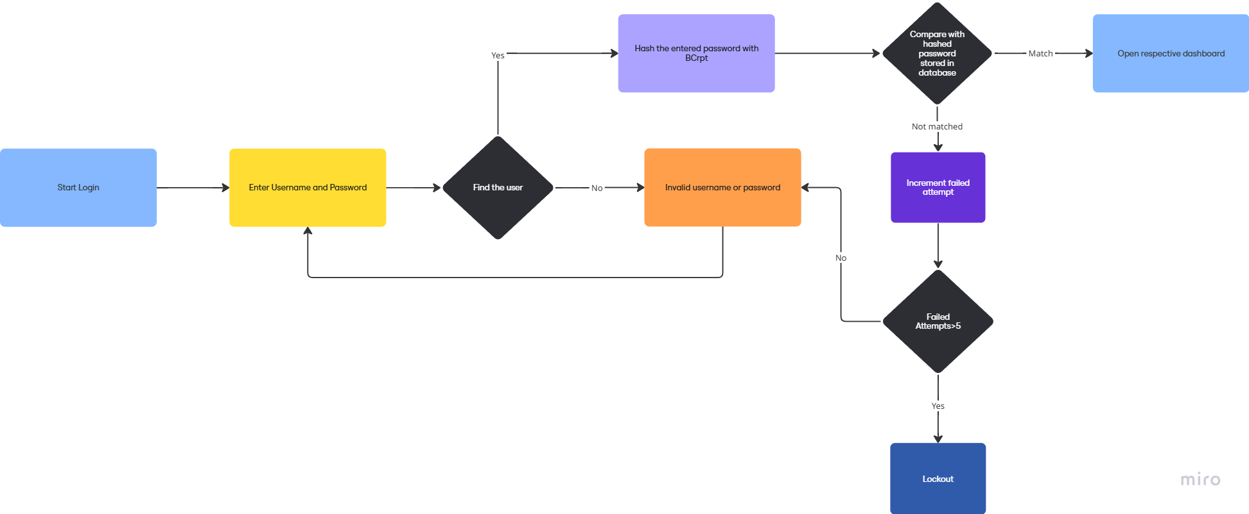

- Student Flow
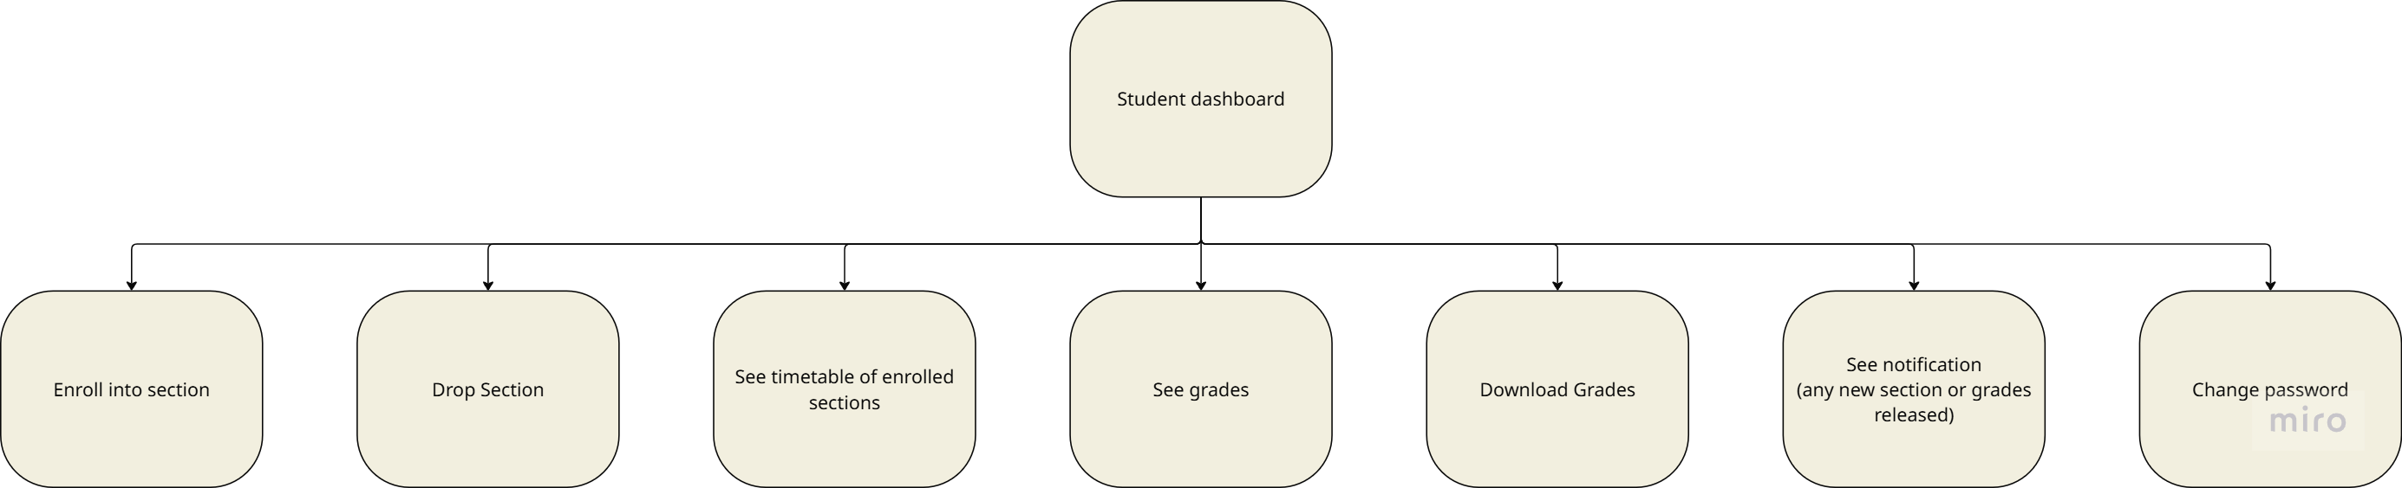

- Instructor Flow
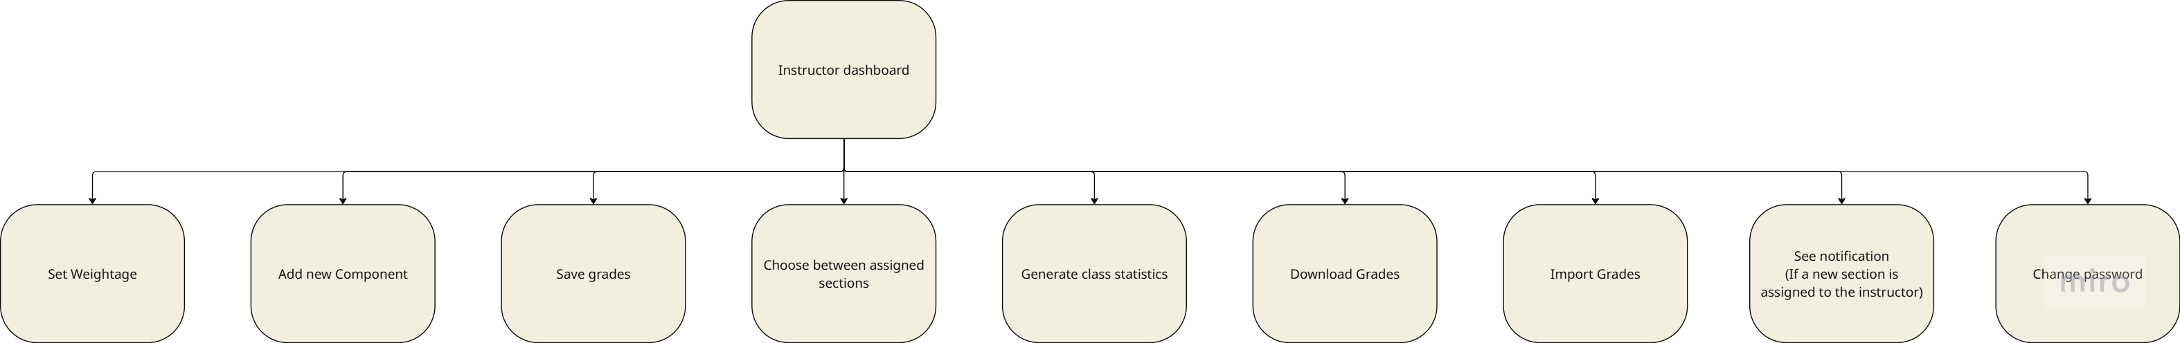

- Admin Flow
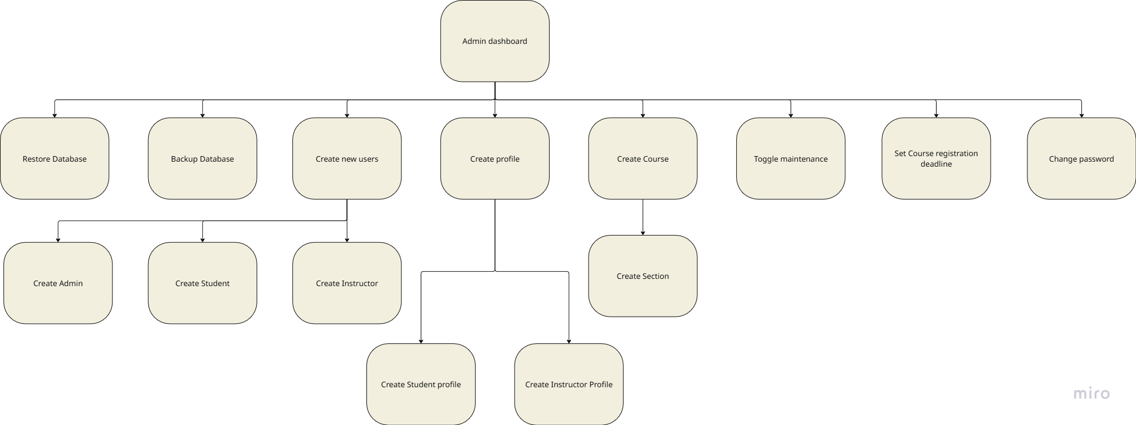

- Relational Diagram
